
Custom BI Report to display User, Roles and Data Access

Disclaimer
The described solutions, options may differ based on the Fusion Cloud application versions. Practice the proof of concept (POC) on your development environment before providing the solution to clients.

Table of Contents
Goal 4
Solution 4
Documents Reference 9

Goal
How to create Custom BI Report to display User, Roles and Data Access in one single report for active and inactive users.

Solution
  - Step1: Create Data Model using below query in Oracle BI Analytics.
Navigation: Tools Report and Analytics Browse Catalog Create Data Model
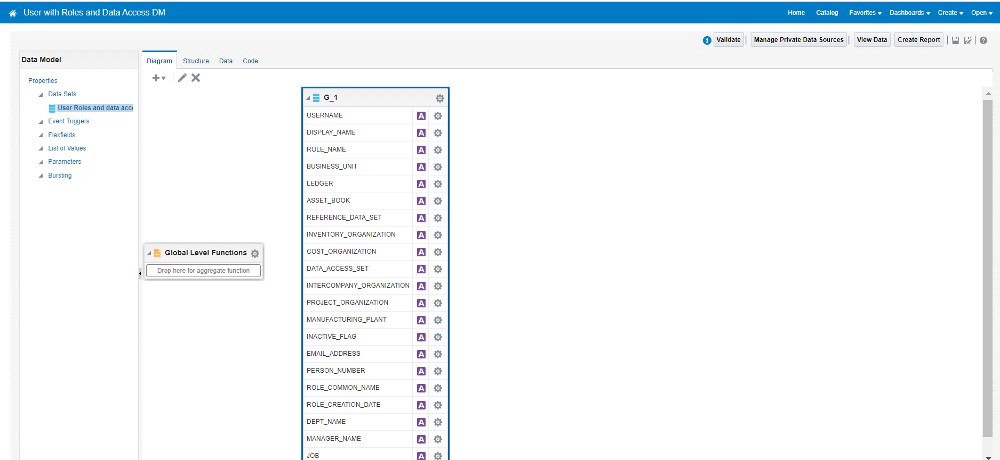
Data Model Query:
SELECT
papf.person_number ,
pu.username ,
pap.display_name ,
prv.role_common_name ,
prv.role_name ,
TO_CHAR(prv.creation_date,'YYYY/MM/DD') role_creation_date,
(
SELECT
LISTAGG(cod.organization_name, ', ') WITHIN GROUP (ORDER BY cod.organization_name)
FROM
cst_organization_definitions_v cod ,
fun_user_role_data_asgnmnts furd
WHERE
cod.organization_id = furd.org_id
AND UPPER(cod.classification_code) = UPPER('fun_business_unit')
AND furd.user_guid =pu.user_guid
AND furd.role_name =prv.role_common_name
AND furd.active_flag = 'Y' ) business_unit ,
(
SELECT
LISTAGG(gl.NAME, ', ') WITHIN GROUP (ORDER BY gl.NAME)
FROM
gl_ledgers gl ,
fun_user_role_data_asgnmnts furd
WHERE
gl.ledger_id = furd.ledger_id
AND furd.user_guid =pu.user_guid
AND furd.role_name =prv.role_common_name
AND furd.active_flag = 'Y' ) ledger,
(
SELECT
LISTAGG(fbc.distribution_source_book, ', ') WITHIN GROUP (ORDER BY fbc.distribution_source_book)
FROM
fa_book_controls fbc ,
fun_user_role_data_asgnmnts furd
WHERE
fbc.book_control_id = furd.book_id
AND furd.user_guid =pu.user_guid
AND furd.role_name =prv.role_common_name
AND furd.active_flag = 'Y' ) asset_book ,
(
SELECT
LISTAGG(fss.set_name, ', ') WITHIN GROUP (ORDER BY fss.set_name)
FROM
fnd_setid_sets fss ,
fun_user_role_data_asgnmnts furd
WHERE
fss.set_id = furd.set_id
AND UPPER(fss.language) = UPPER('us')
AND furd.user_guid =pu.user_guid
AND furd.role_name =prv.role_common_name
AND furd.active_flag = 'Y' ) reference_data_set,
(
SELECT
LISTAGG(cod.organization_name, ', ') WITHIN GROUP (ORDER BY cod.organization_name)
FROM
inv_organization_definitions_v cod ,
fun_user_role_data_asgnmnts furd
WHERE
cod.organization_id = furd.inv_organization_id
AND furd.user_guid =pu.user_guid
AND furd.role_name =prv.role_common_name
AND furd.active_flag = 'Y' ) inventory_organization,
(
SELECT
LISTAGG(cod.organization_name, ', ') WITHIN GROUP (ORDER BY cod.organization_name)
FROM
cst_organization_definitions_v cod ,
fun_user_role_data_asgnmnts furd
WHERE
cod.organization_id = furd.cst_organization_id
AND UPPER(cod.classification_code) = UPPER('cst')
AND furd.user_guid =pu.user_guid
AND furd.role_name =prv.role_common_name
AND furd.active_flag = 'Y' ) cost_organization ,
(
SELECT
LISTAGG(gas.NAME, ', ') WITHIN GROUP (ORDER BY gas.NAME)
FROM
gl_access_sets gas ,
fun_user_role_data_asgnmnts furd
WHERE
gas.access_set_id = furd.access_set_id
AND furd.user_guid =pu.user_guid
AND furd.role_name =prv.role_common_name
AND furd.active_flag = 'Y' ) data_access_set,
(
SELECT
LISTAGG(fio.interco_org_name, ', ') WITHIN GROUP (ORDER BY fio.interco_org_name)
FROM
fun_interco_organizations fio ,
fun_user_role_data_asgnmnts furd
WHERE
fio.interco_org_id = furd.interco_org_id
AND furd.user_guid =pu.user_guid
AND furd.role_name =prv.role_common_name
AND furd.active_flag = 'Y' ) intercompany_organization,
(
SELECT
LISTAGG(cod.name, ', ') WITHIN GROUP (ORDER BY cod.name)
FROM
hr_all_organization_units_tl cod ,
fun_user_role_data_asgnmnts furd
WHERE
cod.organization_id = furd.prj_organization_id
AND furd.user_guid =pu.user_guid
AND furd.role_name =prv.role_common_name
AND furd.active_flag = 'Y'
AND cod.language ='US' ) project_organization ,
(
SELECT
LISTAGG(cod.organization_name, ', ') WITHIN GROUP (ORDER BY cod.organization_name)
FROM
cst_organization_definitions_v cod ,
fun_user_role_data_asgnmnts furd
WHERE
organization_id = furd.mfg_organization_id
AND UPPER(classification_code) = UPPER('inv')
AND furd.user_guid =pu.user_guid
AND furd.role_name =prv.role_common_name
AND furd.active_flag = 'Y' ) manufacturing_plant,
pu.suspended inactive_flag ,
pea.email_address ,
(

SELECT
LISTAGG(ppn.display_name, ', ') WITHIN GROUP (ORDER BY ppn.display_name)
FROM
per_person_names_f ppn,
per_assignment_supervisors_f pas
WHERE
ppn.person_id = pas.manager_id
AND pas.person_id = pu.person_id
AND SYSDATE BETWEEN ppn.effective_start_date AND ppn.effective_end_date ) manager_name
FROM
per_users pu ,
per_user_roles pur ,
per_roles_dn_vl prv ,
per_person_names_f_v pap ,
per_all_people_f papf ,
per_email_addresses pea
WHERE
1 =1
AND pu.user_id = pur.user_id
AND pur.role_id = prv.role_id
AND pu.person_id = pap.person_id(+)
AND NVL(pur.end_date,SYSDATE) >= SYSDATE
AND NVL(pu.end_date,SYSDATE) >= SYSDATE
AND pu.person_id = papf.person_id(+)
AND pu.username not like '%APPID%'
AND pu.username not like '%FAW%'
AND TRUNC(SYSDATE) BETWEEN NVL(papf.effective_start_date,TRUNC(SYSDATE)) AND NVL(papf.effective_end_date,TRUNC(SYSDATE))
AND papf.primary_email_id = pea.email_address_id(+)
--AND pu.username =''
ORDER BY
pu.username,
prv.role_name

Data Model Catalog File:

Step2: Create Report Template for the above data model in Oracle BI Analytics.
Navigation: Tools Report and Analytics Browse Catalog Create Create Report

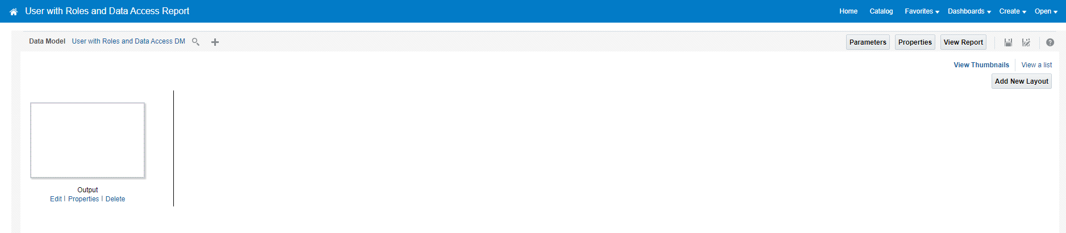

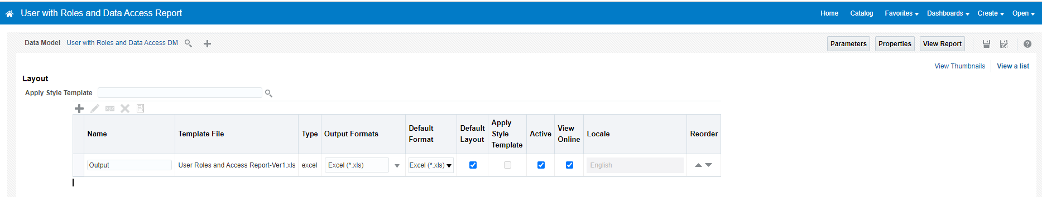

Report Template File:
Report Catalog File:

